Personal Food Relational Database: Pantry
Christian Bridge
INFO 5707.001

Contents
Project Objectives, Scope, and User Requirements: 2
Business Rules: 2
Entity-Relationship Diagram (ERD) - Pantry 3
Data Dictionary – Pantry 4
Creating the Database Tables 6
Customer Table 6
Email Table 6
Customer Email Relationship Table 7
Recipe Table 8
Recipe Customer Relationship Table 9
Food Table 10
Recipe Food Relationship Table 11
Pantry Table 12
Pantry Food Relationship Table 12
Available Queries & Reports 14
Personal Pantry Inventory with Expiration Dates 14
Browse Recipes, Ordered by Difficulty 14
List Recipes which a User Has Ingredients in Their Pantry 15
Recipe Nutritional Information 16
Data for Email to User’s Active E-mail Addresses When Food Is Expiring within 10 Days 17

Project Objectives, Scope, and User Requirements:

Pantry is a personal food database that will help users manage their food inventory, write and save recipes, and assist with finding a recipe based on the food in inventory. This means that the database will need to capture each customer’s: food inventory, information on food items, recipes, and user information. While many of the features are long-term project objectives, our purpose for this initialization is to provide a functional relational database using the framework MySQL.
For this phase, our key requirements for the database are that a customer is able to have a “Pantry”, a user specific table which stores all the food a person currently has at their home. The database will also contain recipes that are contributed by Pantry employees and/or other users. We will create the table to store customer information such as multiple e-mails for future e-mail notifications. Lastly, information on the various foods will need to be stored to calculate nutritional information of recipes, as well as the shelf life of products.
Some of the future ideas that would increase user Quality of Life (QoL), but are not within the scope of this current project, would be GUIs & APIs that allow customers to enter food recently purchased, create recipes, and create queries preferably from a smart device.

Business Rules:

- A Customer is required to have one Pantry.
- A Customer may have many e-mails.
- A Customer may have only one Phone number.
- A Customer must have a Unique Username.
- A Pantry may have several Food Items.
- A Food Item may exist in multiple Pantries.
- A Food Item may exist in multiple Recipes.
- A Recipe may have multiple Food Items.
- A Customer may have many recipes.

Entity-Relationship Diagram (ERD) - Pantry
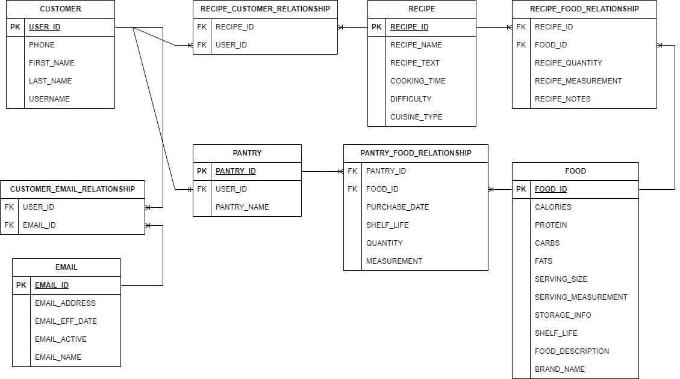

Data Dictionary – Pantry

Table Name | Field Name | Field Description | Data Type | Primary/ Foreign Key
CUSTOMER | USER_ID | Unique ID for User | INT | PK
CUSTOMER | PHONE | Customer Phone Number | VARCHAR(10)
CUSTOMER | FIRST_NAME | Customer First Name | VARCHAR(16)
CUSTOMER | LAST_NAME | Customer Last Name | VARCHAR(16)
CUSTOMER | USERNAME | Customer User Name | VARCHAR(16)
EMAIL | EMAIL_ID | Unique ID for Email | INT | PK
EMAIL | EMAIL_ADDRESS | Email Address | VARCHAR(64)
EMAIL | EMAIL_EFF_DATE | Email Address Effective Date | DATE
EMAIL | EMAIL_ACTIVE | Is Email Address Active? | TINYINT
EMAIL | EMAIL_NAME | User defined name of Email Address | VARCHAR(12)
CUSTOMER_EMAIL_RELATIONSHIP | USER_ID | Unique ID for User | INT | FK
CUSTOMER_EMAIL_RELATIONSHIP | EMAIL_ID | Unique ID for Email | INT | FK
RECIPE_CUSTOMER_RELATIONSHIP | RECIPE_ID | Unique ID for Recipe | INT | FK
RECIPE_CUSTOMER_RELATIONSHIP | USER_ID | Unique ID for User | INT | FK
RECIPE | RECIPE_ID | Unique ID for Recipe | INT | PK
RECIPE | RECIPE_NAME | Name of Recipe | VARCHAR(32)
RECIPE | RECIPE_TEXT | Recipe Instructions/Text | VARCHAR (3000)
RECIPE | COOKING_TIME | Recipe Cooking Time in Minutes | INT
RECIPE | DIFFICULTY | Recipe Difficulty | FLOAT
RECIPE | CUISINE_TYPE | Recipe’s type of cuisine | VARCHAR(32)
RECIPE_FOOD_RELATIONSHIP | RECIPE_ID | Unique ID for Recipe | INT | FK
RECIPE_FOOD_RELATIONSHIP | FOOD_ID | Unique ID for Food Item | INT | FK
RECIPE_FOOD_RELATIONSHIP | RECIPE_QUANTITY | Food Item Quantity for Recipe | FLOAT
RECIPE_FOOD_RELATIONSHIP | RECIPE_MEASUREMENT | Food Item Measurement Type for Recipe | VARCHAR(12)
RECIPE_FOOD_RELATIONSHIP | RECIPE_NOTES | Food Item preparation notes | VARCHAR(64)
FOOD | FOOD_ID | Unique ID for Food Item | INT | PK
FOOD | CALORIES | Total Calories in one Food Item Serving | FLOAT
FOOD | PROTEIN | Total Protein in one Food Item Serving | FLOAT
FOOD | CARBS | Total Carbs in one Food Item Serving | FLOAT
FOOD | FATS | Total Fats in one Food Item Serving | FLOAT
FOOD | SERVING_SIZE | Listed Serving Size of Food Item | FLOAT
FOOD | SERVING_MEASUREMENT | The type of measurement for the Serving Size | VARCHAR(16)
FOOD | STORAGE_INFO | Food Item storage information | VARCHAR(64)
FOOD | SHELF_LIFE | How many days the food stays edible | INT
FOOD | FOOD_DESCRIPTION | Description of Food Item | VARCHAR(64)
FOOD | BRAND_NAME | The brand that made the product | VARCHAR(32)
PANTRY_FOOD_RELATIONSHIP | PANTRY_ID | Unique ID for Pantry | INT | FK
PANTRY_FOOD_RELATIONSHIP | FOOD_ID | Unique ID for Food Item | INT | FK
PANTRY_FOOD_RELATIONSHIP | PURCHASE_DATE | Date Food Item was purchased | DATE
PANTRY_FOOD_RELATIONSHIP | SHELF_LIFE | Time Food Item has in days before going bad | INT
PANTRY_FOOD_RELATIONSHIP | QUANTITY | Number of Food Items | INT
PANTRY_FOOD_RELATIONSHIP | MEASUREMENT | Type of Measurement of Food Items | VARCHAR(12)
PANTRY | PANTRY_ID | Unique ID for Pantry | INT | PK
PANTRY | USER_ID | Unique ID for User | INT | FK
PANTRY | PANTRY_NAME | Name given by User for Pantry | VARCHAR(16)

Creating the Database Tables

Customer Table
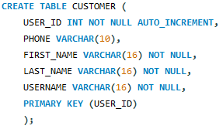
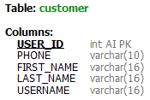
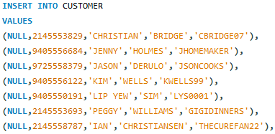
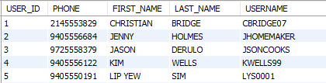

Email Table
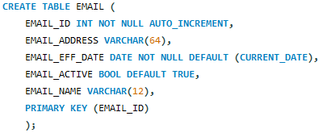
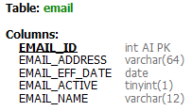
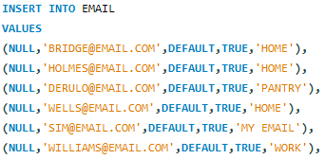

Customer Email Relationship Table
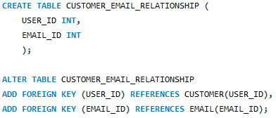
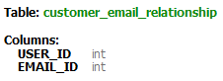
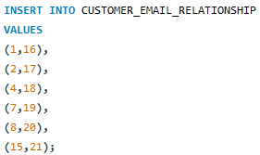
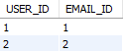

Recipe Table
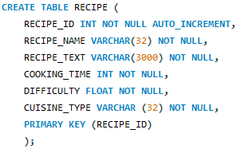
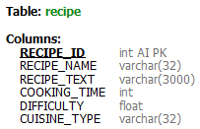
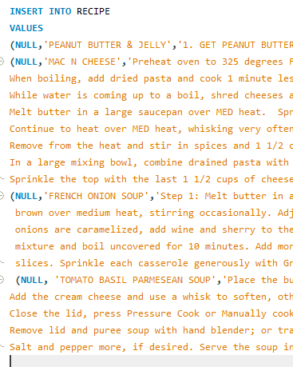
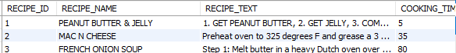

Recipe Customer Relationship Table
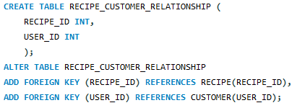

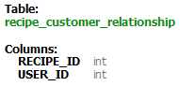
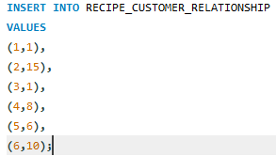
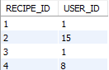

Food Table
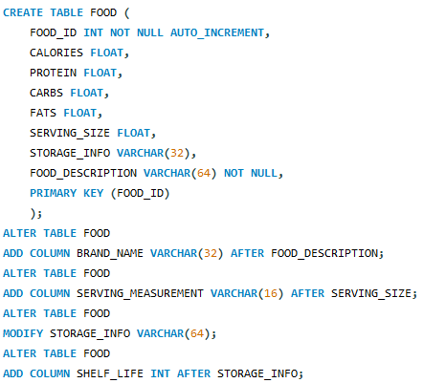
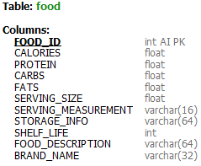
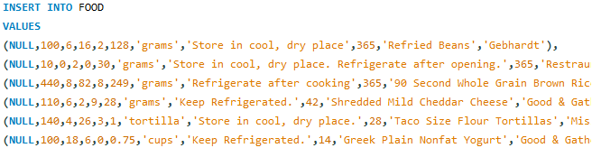
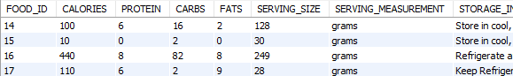

Recipe Food Relationship Table
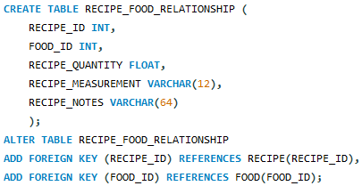
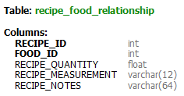
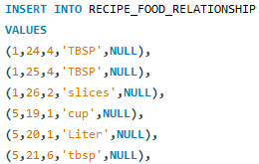
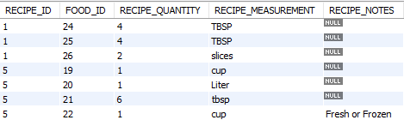

Pantry Table
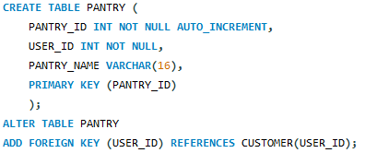
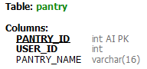
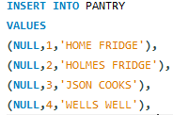
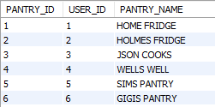

Pantry Food Relationship Table
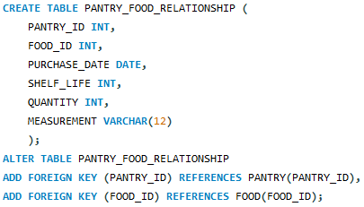
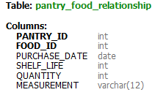
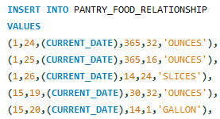
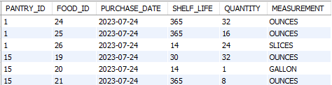

Available Queries & Reports

Personal Pantry Inventory with Expiration Dates
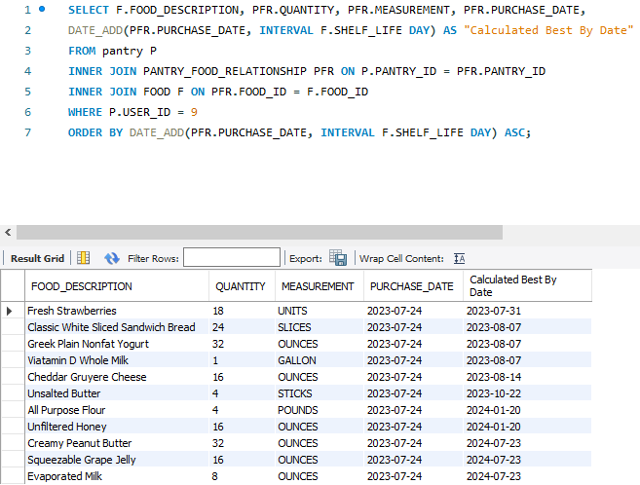

Browse Recipes, Ordered by Difficulty
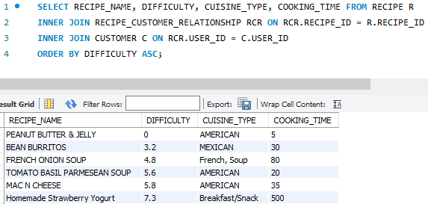

List Recipes which a User Has Ingredients in Their Pantry
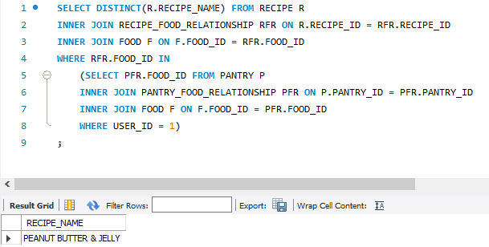
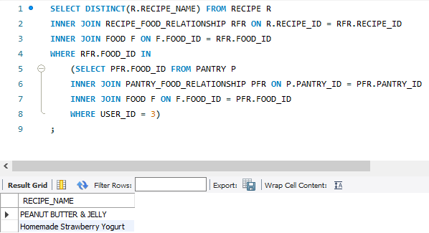

Recipe Nutritional Information
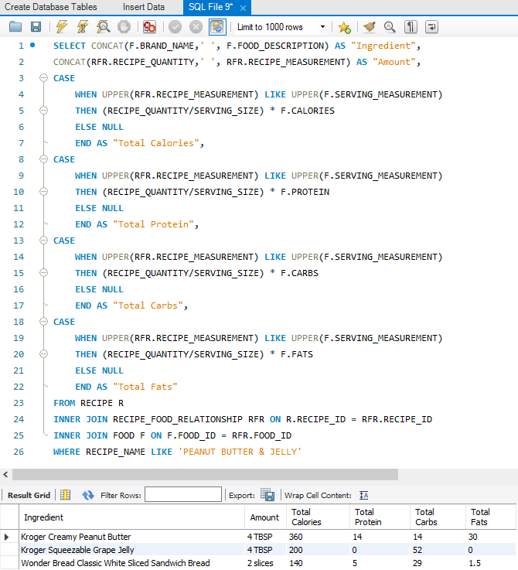

Data for Email to User’s Active E-mail Addresses When Food Is Expiring within 10 Days
